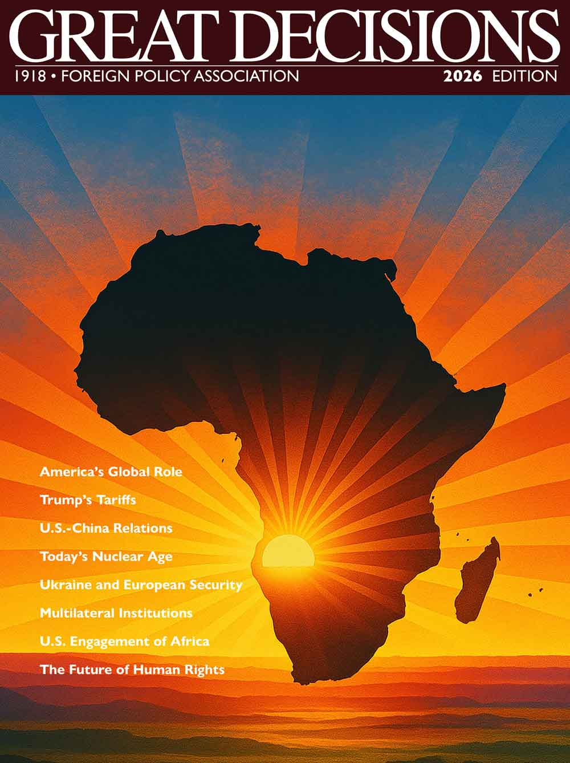

GREAT DECISIONS 2026

Jefferson County Library
& Quimper Village





JC Library - 4 Monday Evenings, 5:15-6:45 PM, Mar 223 (No Signup, Just Come!) OR
Quimper Village - 4 Friday Mornings, 10-11:30 AM, Mar 627 (Required Signup Here)

The Foreign Policy Association (FPA) is celebrating its 108th year. Its roots were in support of President Woodrow Wilson’s advocacy of the League of Nations after WWI. Its mission is to catalyze developing awareness, understanding, and informed opinion on U.S. foreign policy and global issues. Through its balanced, nonpartisan programs and publications, the FPA encourages citizens to participate in the foreign policy process.

FPA’s Great Decisions Program is America’s largest foreign affairs education and discussion program. Launched in Portland, Oregon in 1954, the program gained media attention, was picked up by local schools and colleges, and soon gained national attention.

Each year, the FPA identifies timely global topics and produces a briefing book, a DVD, and multiple online resources to engage and inform participants. FPA staff then seeks to poll and widely publicize (to government agencies, international affairs groups, and the public) what foreign policies GD participants support.

Each week, we’ll view the GD video and sometimes videos from other commentators, then discuss the U.S. foreign policy options introduced in each section. You’ll be asked to offer your opinions on each topic through an online survey at https://fpa.org/topics/. This is your chance to be heard!

2026 dates and topics - (Note: We expect to be covering only 4 of the 8 topics offered, and the selected topics could change as new events occur. The GD materials were produced in the Fall of 2025 to be ready for distribution in the New Year.)
- Mar 2 or 6 – Debating America’s Global Role: America First v. Liberal Internationalism
- Mar 9 or 13 – The Third Nuclear Age: Trump, The Order, and the Bomb
- Mar 16 or 20 – Ukraine and the Future of European Security
- Mar 23 or 27 – Multilateral Institutions in a Changing World Order

The Great Decisions 2026 Briefing Book can be purchased at https://fpa.org, but it is pricey, and we will only be using half of it for this class. The book and accompanying CD Rom will be on reserve at Jefferson County Library and available at Quimper Village. The book is also available as an e-book through Libby. If you check it out, please keep it only long enough to read the chapter for that week, then return it so others can access. Additional Resources for Each Topic are available at https://fpa.org/topics/

The Great Decisions program is an outreach of the Salish Sea Fellowship through its Adult Learning Programs (ALPs), a free community service. For the full description of all our Spring 2026 ALPs offerings and signup instructions, select the ALPs Brochure button at our Salish Sea Fellowship website (https://www.salishseafellowship.org/).

Joyce Francis, Ph.D. has facilitated the Great Decisions program on Quimper Peninsula since 2011. Joyce taught International Relations at George Mason, Tulane, and American University prior to moving to the Olympic Peninsula in 2008. For further information about Great Decisions 2026 or the ALPs program, contact Joyce at joyce.francis.pt@gmail.com.

Grading (AF) of Post WWII Presidents’ Foreign Policies

- Truman (1945-53) - Victory in Japan, U.N Established, Truman Doctrine, Berlin Airlift, NATO Established, Korean War.
- Eisenhower (1953-61) – Warsaw Pact, Suez Crisis, Sputnik
- Kennedy (1961-63) – Bay of Pigs Invasion, Cuban Missile Crisis
- Johnson (1963-69) – Vietnam War, 6-Day War, Nuclear Non-Proliferation Treaty
- Nixon (1969-74) – Visit to China, Yom Kippur War
- Ford (1974-77) – Nothing of Note
- Carter (1977-81) – Camp David Accords, Salt 2 Agreement, Iranian Revolution, Soviet Invasion of Afghanistan
- Reagan (1981-89) – Iran-Contra Affair, Nuclear Intermediate-Range Nuclear Force Treaty, Fall of Berlin Wall
- Bush I (1989-93) – Tiananmen Square, Gulf War, Collapse of Soviet Union, Maastricht Treaty Creating EU
- Clinton (1993-2001) – Rwandan Genocide, NAFTA
- Bush II (2001-2009) – 9/11, Invasion of Afghanistan & Iraq
- Obama (2009-2017) – Russia’s Annexation of Crimea, Iran Nuclear Deal
- Trump 1 (2017-2021) – U.S. Troups Out of Syria, N. Korea Summits, Revision of NAFTA, Abraham Accords, Cancelled Iran Nuclear Deal
B

